# OS Assignment 2

## Question 2 – Readme

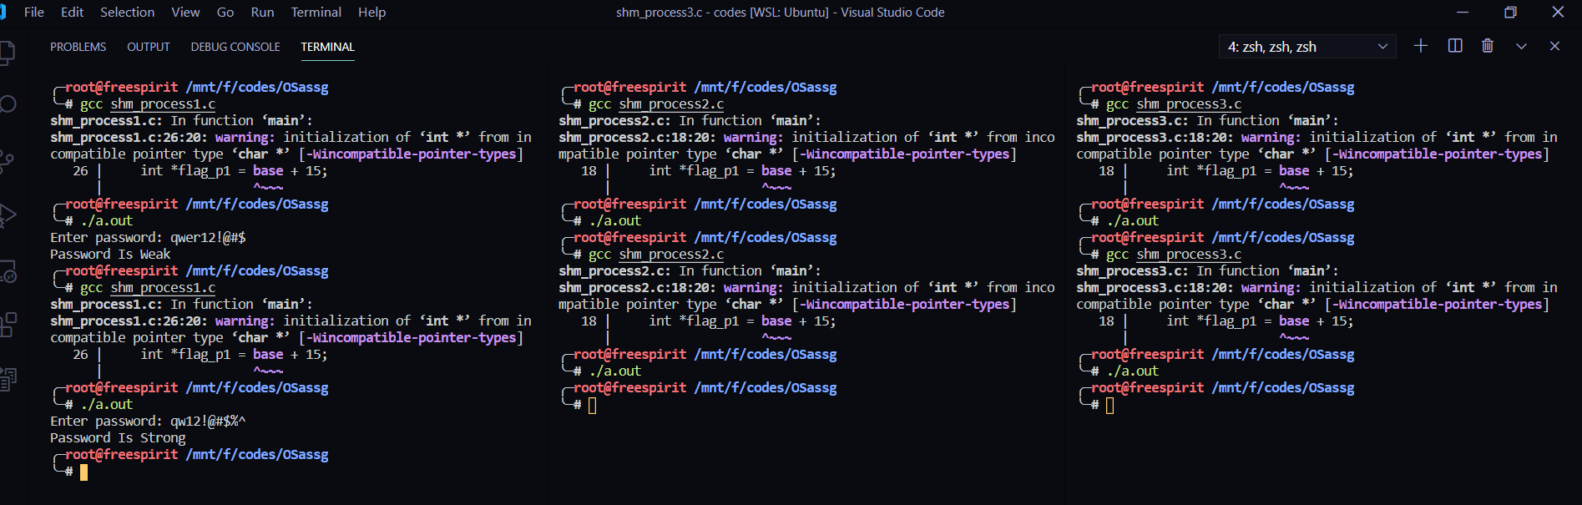***IPC using shared memory:***

***Processes:***

shm_process1.c - Reads a password(string) from the user,

displays whether password is strong or weak

shm_process2.c - Calculates the number of alphanumeric & special characters

shm_process3.c - Calculates strength of password

***Shared Memory:***

pw: password (10 characters)

flag_p1 : process 1 lock

flag_p2 : process 2 lock

flag_p3 : process 3 lock

alnum : number of alphanumeric characters

spc : number of special characters

strength: strength of password